**CONFUSION MATRIX**

import matplotlib.pyplot as plt

import seaborn as sns

from sklearn.metrics import confusion_matrix

class_labels = ['EOSINOPHIL', 'LYMPHOCYTE', 'MONOCYTE', 'NEUTROPHIL"]

cm = confusion_matrix(y_test, pred2)

plt.figure(figsize=(10, 7))

sns.heatmap(cm, annot=True, fmt='g', vmin-e, cmap='Blues')

plt.xticks(ticks=[0.5, 1.5, 2.5, 3.5], labels=class_labels)

plt.yticks (ticks [8.5, 1.5, 2.5, 3.5], labels=class_labels)

plt.xlabel("Predicted")

plt.ylabel("Actual")

plt.title("Confusion Matrix")

plt.show()

**OUTPUT :**

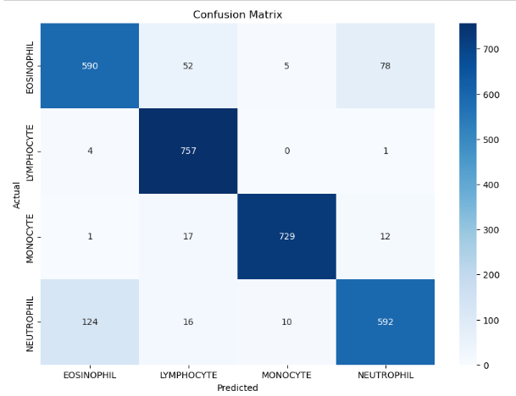

* Shape: 4×4 grid (since you have 4 classes).
* Axes Labels:  
  + X-axis (columns): Predicted class names
  + Y-axis (rows): Actual class names
* Class Names:  
  + 'EOSINOPHIL', 'LYMPHOCYTE', 'MONOCYTE', 'NEUTROPHIL'
* Numbers in Cells: The count of predictions.  
  + Diagonal values (e.g., [0,0], [1,1]) represent correct predictions.

Off-diagonal values represent misclassifications.